



# **Department of Computer Science**

# **CPSC 490 / 491 CAPSTONE PROJECT PROPOSAL**

# 

# **AUTHOR(S)**

# 

|  |  |  |
| --- | --- | --- |
| **Student Name** |  | **Student ID** |
|  |  |  |
|  |  |  |
|  |  |  |

|  |  |
| --- | --- |
| Proposal Date: |  |
| Completion Deadline: |  |
| Tentative Title: |  |

# 

|  |  |  |  |
| --- | --- | --- | --- |
| Faculty Proposal Advisor |  |  |  |
|  | Printed name | Sig Signature | Da Date |

# 

Table of Contents

Abstract 3

1. Introduction 3
   1. - Executive Summary 3
   2. - Terms and Acronyms 3
   3. - Objectives 3
2. Project Scope 5
   1. - Project Description 5
   2. - Use Case Diagram 5
   3. – Data Flow Diagram 8
   4. – Operating Environment and Dependencies 8
   5. - UI Mockup Screens 9
3. Methodology 10
   1. - Technical Approach 10
   2. - Project Timeline 10

3.3- Task Breakdown 11

1. Related Work 12
   1. - Literature Review 12
2. Stakeholders, Users and Benefits 13
   1. - User Identification 13
   2. - User Need and Benefits 14
3. Technical Architecture & High-Level Design 15
   1. - System Architecture 15
   2. - Referencing Stakeholder Concerns 16
   3. - Data Flow 16
   4. - High-Level Design 17
   5. - Security Architecture and Design 17
4. Project Management 18
   1. - Roles and Responsibilities 18
   2. - Communication Plan 19
   3. - Risks and Risk Management 19
5. Evaluation and Assessment 21
   1. - Success Criteria 21
   2. - Testing Plan 21
   3. - User Evaluation 22
   4. - Measurement of Benefits 23
6. Ethical Considerations 24
7. Conclusion 25

References 26

# Abstract

# Introduction

This section describes the overall project and foundation of the application: CarCrash101.

## - Executive Summary

Getting into a car accident whether big or small can be a tricky situation to navigate; with CarCrash 101, drivers of all ages will be able to be guided via the application to address the accident safely and as calmly as possible. With an engaging yet streamlined user-friendly experience, all persons involved in the accident will have the ease to gather all the necessary information after an accident has occurred in an accessible format, and without the extra stress. Oftentimes, it’s easy to say that you are prepared for an accident; when it happens, there are many outstanding factors which make it difficult to remember; with CarCrash101, the goal is to make conversations with the insurance and police and aftermath process less of a headache to deal with.

* 1. *- Terms and Acronyms* AI = Artificial Intelligence AWS = Amazon Web Services

Application = Mobile App, or if website route is pursued

## - Objectives

This product will be developed to assist users in the aftermath of a car crash and

# Project Scope

This section includes the general structure and planning taken for organizational and outline purposes.

## - Project Description

This project is made for all drivers, young and old. It’s easy to forget to take pictures of the car, collect the other driver(s) information, and more; this product will assist and guide users in a seamless process so not only will the direct moment after the crash be easier, as will the lengthy insurance communications in the weeks and months following the incident.

## - Use Case Diagram

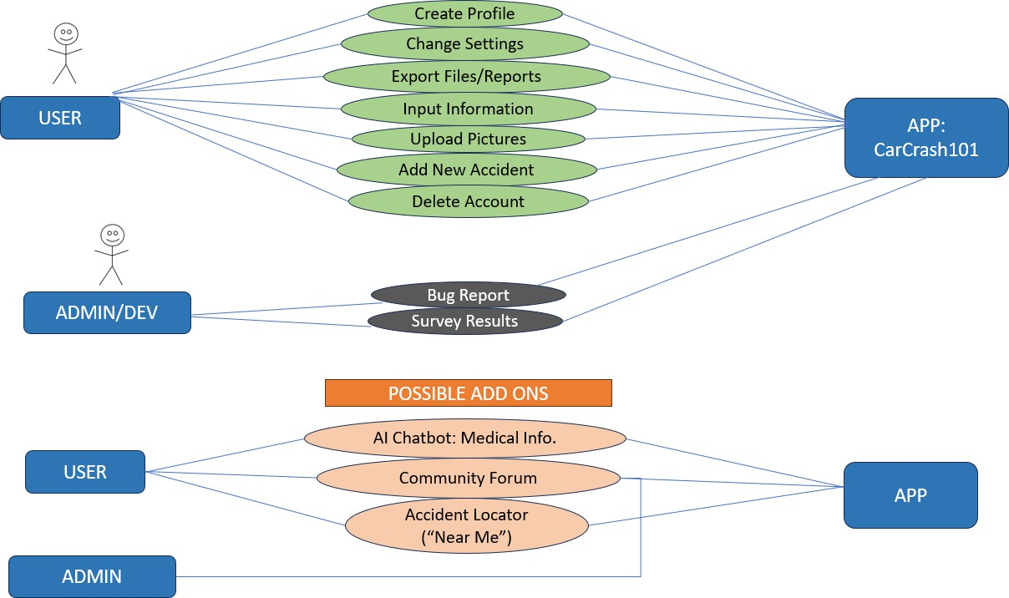

* 1. *– Project Deliverables*

An app which generates helpful forms, safety tips, and stores information about current and past car accidents, with the caveat that they were inputted into the app. Users will be able to load in their profile information, review past collisions, and add new accident information when a collision has occurred. Finally, their inputted data will be converted to a police report and insurance form, and can be exported as necessary for the individual to send off, save, or print. Please refer to the following list for outlined functions within the deliverable as stated above:

* + - Functional App for both iOS and Android operating systems: Home Screen, Profile, New Accident, Feedback pages
    - Database Management: Profile, New Accident, Accident History
    - Form Filling capabilities: Insurance, Personal, Police (pdf export available)

In addition to general features, the application will have one or more of the following additional abilities should time permit. Please note that each of these additions are tentative at this time.

* + - Artificial Intelligence Chatbot
      * Communication of the user with the chatbot for safety tips and to record health and wellbeing information after the accident has occurred for additional documentation.
    - Crash Detection
      * Similar to the apple watch fall detection monitor, this feature will identify a crash and respond with a notification to open the app. Possible extensions

are the ability to tap to call/speak to call emergency services or send an automated text to family members/emergency contacts.

* + - Community Forum and Accident Navigator
      * This extension can be compared to the Ring Doorbell notifications; when a major accident has occurred within a given number of miles from the user’s location, the community forum for those accidents will be at the top of the user’s feed. This will allow bystanders and other individuals to support each other as needed.
    - Web-View
      * This extension would make exporting documents and reviewing past data in an easier fashion. Since the website would be directly connected to the database storing the user’s profile on the app, changes can be made and information can be retrieved. Users can login with the same credentials as used for the app to access their data.
  1. *– Project Limitations*

Some limitations with this project include the database storage. As the developer, I will need to be conscious about this and approach this possible limitation as well as phone access in regards to what platform I build the app on. Amazon Web Services and Google Firebase both support mitigation of this possible limitation; however there may be cost involved. The goal is to ensure a reasonable project budget, which may reflect possible project extension pathways and extensions. Research on the development

environment is ongoing and will be solidified by the commencement of the project development lifecycle.

## – Data Flow Diagram

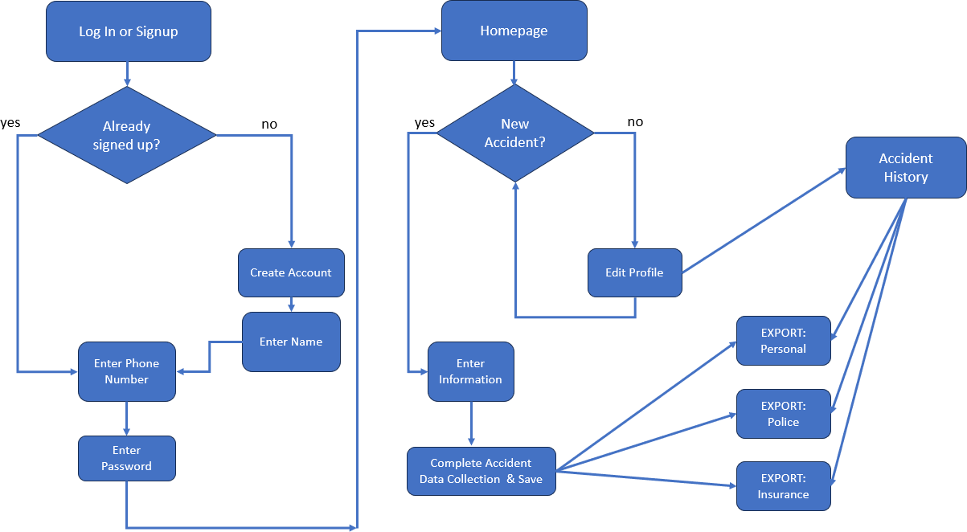

## – Operating Environment and Dependencies

I will be using GitHub to save my ongoing development work, coupled with the use of Amazon Web Services AWS and Google Firebase. Note that these environments are tentative, with confirmation following the beginning stages of development and commencement of the project. As a developer, I will need to take time to learn how to operate in these environments and will be adjusting or pivoting to others as needed. The goal is for the application to be out on the IOS AppStore and Google Play Store, being operable on smartphone devices. After discussions with my proposal advisor, there exist cross-platform frameworks such as React Native, and supporting software.

See below for the two options in terms of platforms:

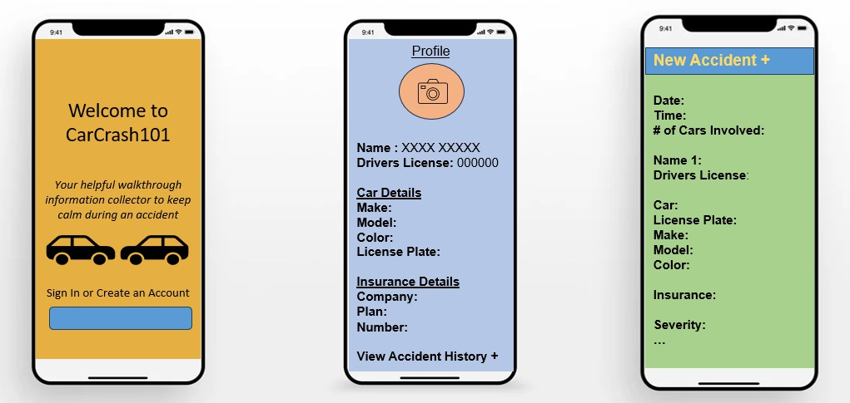

App: The app will be available on the IOS AppStore and Google Play Store for general use. This may cost an initial developer account fee as needed. At this time, this is the current approach in completing this project.

Website (backup): The website will be open to the public and accessible from both desktop and mobile versions. The website may incorporate aspects of artificial intelligence and general web design features.

## - UI Mockup Screens

# Methodology

As a single developer of this project, I will be responsible for wearing the many hats and assume following responsibilities, including but not limited to: developer, project manager, QA, technical writer, etc.

## - Technical Approach

Since I will be creating an app, I will need to learn some skills to do so; as someone who does not have too much experience using React Native, and in app development, there will be a learning curve. To approach these new skills, I will be watching YouTube and practicing these frameworks in advance to prepare for the execution of this project. I will start practicing in Visual Studio/Visual Studio Code till an IDE (if a different one is needed) is identified that fits my needs for the development of this project. In regards to the tentative enhancements, I will use my current knowledge of artificial intelligence, and developing app development skills to grow the project further should time permit.

Note that additional programming skills such as Python, C++, HTML/CSS (website) may be used as needed.

## - Project Timeline

I will begin the project at the beginning of the semester (either in January or August) and have a working product with designated features up and running by the beginning of March. From there, I will approach the project with two-week sprints to complete the additional features, ensuring that every two weeks the project is in running condition and can be viewed in progress from March to the deliverable date in mid-May. I will be

adopting a SCRUM format of project management and use the methodology to run the project lifecycle. Given the need for a strong, well protected and constructed database, I plan to spend additional planning time at the beginning of the semester before fully constructing the user interface and other features that all play into the database.

## 3.3- Task Breakdown

Starting with learning some basic app development to set up the dev environment, I will then move to the form processing and database setup. This is a key step as it will be holding the data securely and needs to be in communication with the app itself. I will then be implementing the user interface, saving of profile data as well as accident data, and creating exportable pdfs to satisfy the needs of this project. Should time permit, I will add additional features as outlined in section 2.3 of this proposal. As mentioned in the previous section (3.2) I will be using SCRUM to keep the project on track for the 13 weeks of development, and 2 weeks for cleanup. Using this methodology will assist in not only the completion of set requirements for a minimum viable product, but also account for other responsibilities throughout the semester of development.

# Related Work

This section includes an overview of the conceptual aspect of this project and how this app will assist drivers and adapt to the changing of the times.

## - Literature Review

I have researched and communicated with family members that have been involved in a car crash to understand what the process is like. I continue to research how the police reports are formatted, and what are the most important safety tips when composing yourself and addressing the accident at hand from both the cause and victim perspectives. In the 90’s, it was encouraged for all drivers to keep a checklist in their glove compartment, for reference when a collision occurred. With technology advancements, and for greater usage, an app that users can have installed on their mobile devices will provide a similar convenience and support. With the tentative implementation of crash detection, we can take a step up from the paper reference sheet as a simple notification from the app will remind the driver of the existence of the app and to use after a collision.

# Stakeholders, Users and Benefits

This section outlines the different stakeholders, users and how the app will be made to satisfy the overall need and concerns of the user.

* 1. *- Stakeholder Identification*

Stakeholders in this project include the police, insurance companies, the at-fault, and no-fault (victim(s)). Each of these parties are key persons when an accident has occurred. Individuals involved in an accident can be categorized into two categories: stressed and extra stressed. Being involved in a collision can be nerve wracking, and cause emotions to be in a blunder. This product will consider the two general types of personalities involved in the accident, and allow users to opt in for a moment of calm as they navigate through the beginning prompts within the app.

## - User Identification

This product will target all drivers and help both the at-fault and not-a fault individuals gather the proper information after an accident. This information will be able to be exported to the police and insurance companies to assist with the reports and processing.The app will be available to all mobile phone users, and make the aftermath of smaller accidents streamlined. Users of the app will be prompted to either login or set up an account; all it takes is your phone number and then a password. This will make it easy for users to access the app with their credentials since they will be using their phone to download and use the app anyways.

## - User Need and Benefits

This project addresses the struggle in the collection of information after a car accident has occurred. Oftentimes there can be missing information, ultimately making the insurance processing take months with great struggle to resolve. Pictures of the cars involved as well as the possible debris around the site of the accident are just as important; this way, the accident is detailed as much as possible and the evidence is present if applicable. This project will assist in the data collection process after an accident and provide necessary information with fewer holes to streamline individual disputes with the insurance company.

# Technical Architecture & High-Level Design

This section outlines the system architecture and the relationships within the design features.

## - System Architecture

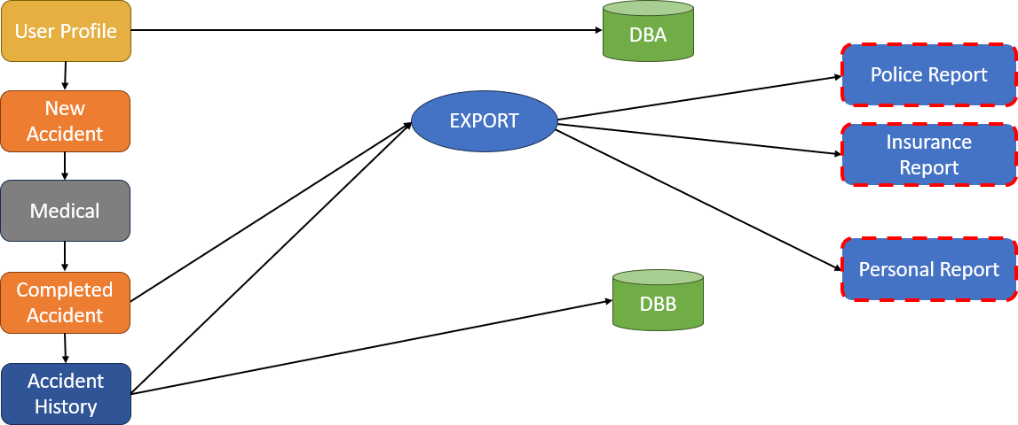

Note: The read dashed outline reflects the tentative enhancement of web development and application usage, where users can access the reports online through their portal. What will be included in the app, will be a form filler and import pictures section. There will be multiple picture import sections to ensure the person is taking pictures from all necessary angles of the car(s). Since this app is made for individuals with smartphones, camera access should be available. If someone uses the technology after the accident has occurred, then they will also be able to import from the camera roll. As mentioned in section 2.3, should time permit, there may be an addition of an AI chatbot which will

help record and plot a person’s health before and after an accident, otherwise, a similar feature will be added within the regular accident form.

## - Referencing Stakeholder Concerns

Individuals may be unsure how to use the app; we want to make it an easy use/tutorial/training videos as well to help with this. Police and insurance might mention that it’s harder to fight for the money; however, this app will benefit all, though in different measures. Regarding the police and insurance companies, forms and basic information is able to be sent to them in an easy to read format. From the users’ side, the hassle of dealing with the insurance companies is limited. The app will need to be structured in an accessible manner with different text sizes and fonts so information can be easily read and understood by users of all ages with possible examples of how the information should be entered.

## - Data Flow

Data will flow through the form, to be populated into other forms (police, insurance, personal). The information will then be stored in a database, which will be accessible from the user’s account credentials. All the imputed information by a user will be able to be accessed within the app. Please refer to the system architecture section (6.1) for a visual representation of these processes.

## - High-Level Design

As the user opens the app, they will be prompted to sign in or create an account. From there, they will be able to view their profile, accident history, or create a new accident. With a familiar google form view, the new accident can be populated into the designated sections then converted/filled to specific forms pdf which can be exported to send to necessary parties. Depending on the scale of the accident and database capacity, the populated pdfs will be stored for 1 year till they will be removed, and the user will have access to only high level information about the accident. Both the front and backend of this app will be streamlined and account for the different individuals using the app. All specifics in terms of what the form will consist of will resemble police/insurance company incident forms [References: 1-3].

## - Security Architecture and Design

This aspect will be determined by the chosen development platform. Both Amazon Web Services and Google Firebase have the ability to incorporate additional paid features to mitigate security risks. Given the sharing of personal data and information within the app, this is a factor that needs to be considered, and its placement within the database. Once the foundational app development in React Native is complete, the determination and structure of the app will evolve to navigate these concerns.

# Project Management

This section outlines the roles and responsibilities of the developers and advisors of the project, communication plan, and potential risks and how to address them.

## - Roles and Responsibilities

I will take on the role to organize and execute the project. I will need to manage and take on the project responsibilities as well as the design/development considerations as outlined in the below.

Under the guidance of advisor: Bruce McKenzie, the current proposal advisor for my requested project, I will assume all responsibilities and learning curves. I currently do not have experience developing an application, however, with resources both online and the professor’s academic content, the project will run smoothly.

As a individual completing this project, I will undertake the following:

* + - Research and Design
    - SCRUM-like project management applicable to a single-developer product
    - Testing and Execution
    - Reflection and Evaluation
    - Progress and Planning

## - Communication Plan

This project will be completed solo; however, I will reflect each week in terms of the application progress and ensure I am staying to the weekly/monthly established goals. Please refer to section three for a detailed breakdown of the project task timeline. At this time, I will plan to meet with said advisor as outlined in the previous subsection (7.1) to discuss my progress and receive guidance throughout the development lifecycle and semester.

## - Risks and Risk Management

Some risks by pursuing this project are the following:

* + - Security and Data Storing Concerns: This project will be dealing with personal identifiable information, otherwise known as PII. PII can be a security risk as if there is a data leak, can cause stolen identities, unstable usage of the app, and loss of trust and credibility in the product. To address these concerns, from a security perspective, the defense and database will need to be built up to support this need.
    - Learning App Development Skills: This project will be the first time attempting to develop an app. As a student who has not yet been exposed to these skills, I will be spending time researching and practicing, ultimately using some of the allotted project hours on doing so to be prepared for the development stage(s).
    - Dedication of Time: I am a student involved in a myriad of extracurricular activities as well as have other commitments. I will keep this into consideration

when planning my schedule once I have chosen the semester to complete this capstone project.

# Evaluation and Assessment

This section outlines the evaluation criteria, general user interface goals, and user evaluation methods.

## - Success Criteria

The criteria will start with basic features such as profile establishment, insurance and police report filling, with saved data to the database for easy access. There will be testing with random data to ensure the system is pulling and storing the correct information in the database.To expand on this application some or all of the following (tentative) will be implemented, and evaluated as so:

* + - Artificial Intelligence Chatbot - This will take some time to construct and may be evaluated based on output and how the user is able to see/use the information.
    - Crash Detection - This will require a different path of application, and testing using phones and devices.
    - Community Forum - This will involve multiple users and a developer feedback channel/survey to gather instant feedback from users for debugging. Note: This may require additional sub-criteria given the complexity of information stored and communication features of the application.

## - Testing Plan

This app will be tested every month to ensure it’s stable, running, and can handle basic form tasks. The goal of the product is for it to be working, and accessible for all users,

both tech savvy and not. By enhancing the standard form filling features, the product will progress each month to meet the criteria for completeness each month. When the project commences, this criteria will be better solidified to meet the project and developer (myself) needs.

## - User Evaluation

Feedback will be collected in a 2-3 question form including a star rating as well as a space to provide feedback on the app. People do not typically want to spend time filling out forms, but in this popup, people can share any questions that admin can assist with/debug. With this ability for the user to share feedback, direct to the developer, all users will be able to evaluate the application in a relaxed format and have a greater effect on the functionality.

From a developer perspective, I will be evaluating the product every two weeks using the following components:

* + - User Friendly Experience
    - Encompassing Basic Features: Profile, New Accident, Archived Accidents
    - Form Filling Abilities: Police, Insurance, Personal
    - Database Storing

The list above is accurate to date to evaluate and address the product itself. Should any number of the tentative plans for expansion be included, the project will widen in scope, and additional evaluation techniques may be included in future reports.

## - Measurement of Benefits

To measure the benefits the users are getting by using the application, I will consider the number of downloads, accounts made, and user survey/developer feedback survey. Each of these avenues will allow for quick feedback and response from a myriad of people for debugging purposes, accessibility, and popularity to assist with the success of the application and future extensions/possible enhancements.

# Ethical Considerations

Security of the database as well as the overall storing of personal information. Society trusts multiple companies when it comes to the divulging of personal information; however, given this is a standalone app, credibility may be questioned and I will need to consider how I will regulate information management and ensure users that their data is safe. The goal is to make the database as secure as possible to mitigate this concern. Additionally, ensuring transparency with users, will assist in the efforts as well, and ensure users are agreeing to how their data is stored or shared. Another thing to consider is the accessibility of the app. Those that are older, may not know fully how to operate the app, thus, keeping in mind the inclusivity features of the app, and user support through feedback forms will be included.

# Conclusion

In conclusion, not only will this product be free on the app store for general use, it will allow all drivers, old and young to use this app to assist in the situation following a car accident. With a streamlined user interface and accessible range, CarCrash 101 will aid and promote driving safety and allow individuals to be focused on recuperating after an accident rather than dealing with complex conversations with the insurance companies, and unnecessary hassle*.* This application was made for all individuals and with the goal of expansion of the app and its features as the development process begins.

# References

* 1. *Collision Report - CHP 190*, [www.chp.ca.gov/notify-chp/collision-report-chp-190.](http://www.chp.ca.gov/notify-chp/collision-report-chp-190) Accessed 08 Dec. 2023.
  2. Corporation, Progressive. “What to Do after a Car Accident.” *Progressive*, 4 June 2023, [www.progressive.com/answers/what-to-do-after-car-accident/.](http://www.progressive.com/answers/what-to-do-after-car-accident/) Accessed 08 Dec. 2023.
  3. *Forms*, [www.chp.ca.gov/forms.](http://www.chp.ca.gov/forms) Accessed 08 Dec. 2023.
  4. *Google Firebase*, Google, firebase.google.com/. Accessed 08 Dec. 2023.
  5. “Installing Chocolatey.” *Chocolatey Software*, chocolatey.org/install. Accessed 08 Dec. 2023.
  6. “PM.” *Amazon*, Price Milburn, 1979,

aws.amazon.com/pm/amplify/?trk=fdccefb7-e2ae-4e26-a6c5-23f1e06392a7&sc_channel

=ps&ef_id=Cj0KCQjw-pyqBhDmARIsAKd9XIN5-sNxU8rp5LWWLpwHq2n3--exWo0 PvNhcdv9vi07OuBfw3MPYUasaAm3dEALw_wcB%3AG%3As&s_kwcid=AL%21442 2%213%21651784483672%21p%21%21g%21%21mobile+app+development%2119852 662131%21145019260217. Accessed 08 Dec. 2023.

* 1. “React Native · Learn Once, Write Anywhere.” *React Native RSS*, reactnative.dev/. Accessed 08 Dec. 2023.
  2. “Report of Traffic Accident Occurring in California (SR-1).” *California DMV*, 17 Nov. 2023, [www.dmv.ca.gov/portal/dmv-virtual-office/accident-reporting/.](http://www.dmv.ca.gov/portal/dmv-virtual-office/accident-reporting/) Accessed 08 Dec. 2023.
  3. “Report of Traffic Accident Occurring in California (SR-1).” *California DMV*, 17 Nov. 2023, [www.dmv.ca.gov/portal/dmv-virtual-office/accident-reporting/.](http://www.dmv.ca.gov/portal/dmv-virtual-office/accident-reporting/) Accessed 08 Dec. 2023.
  4. “Welcome to AAA Cluballiace.” *Auto & Roadside Assistance Club | AAA Club Alliance*, cluballiance.aaa.com/. Accessed 08 Dec. 2023.